**DATABASE TASKS**

1. ER diagram for Hospital management system

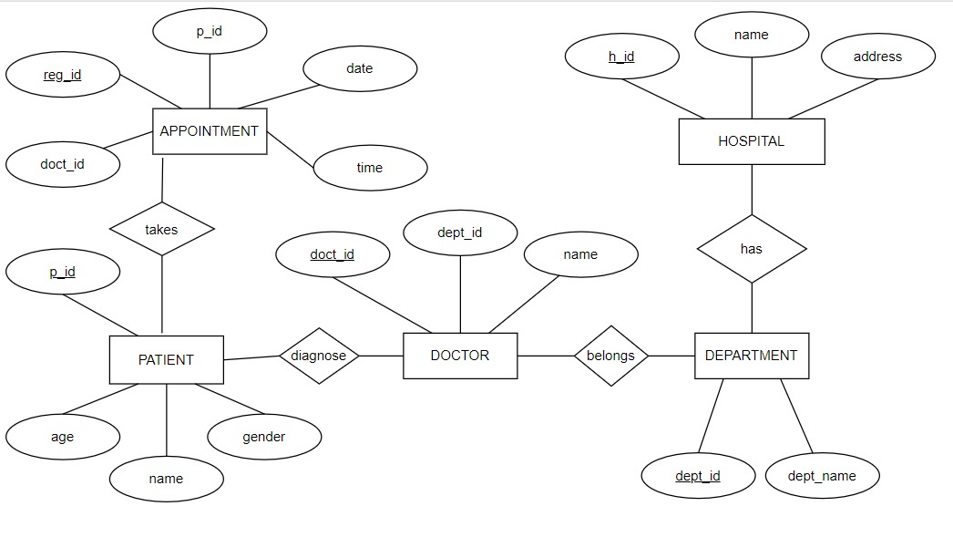

1. Tables respective to ER diagrams

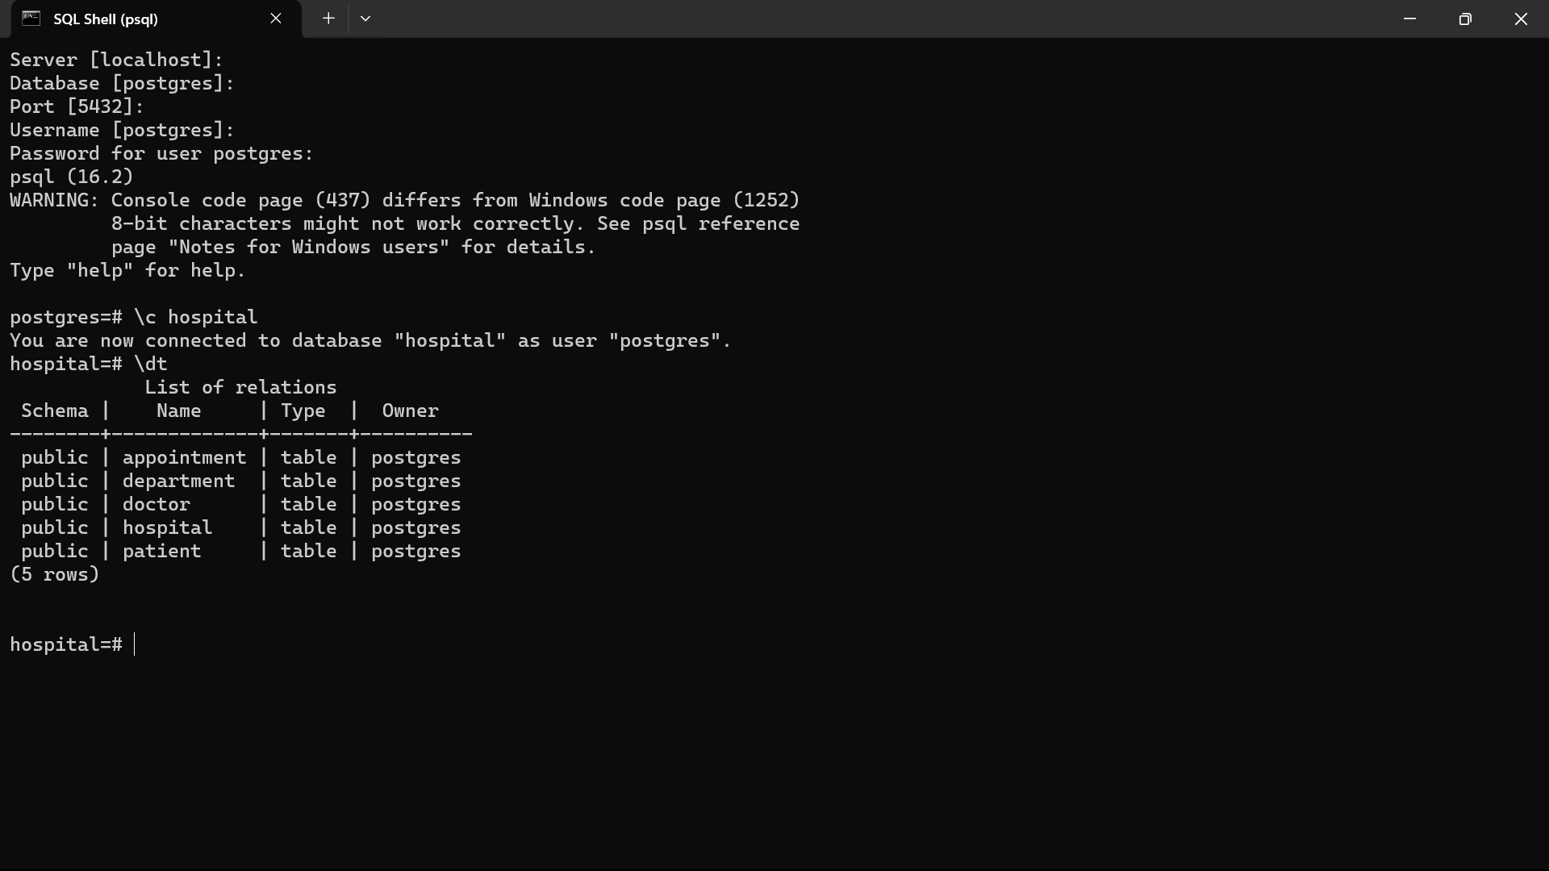

1. Data to each table with minimum of 100 rows.

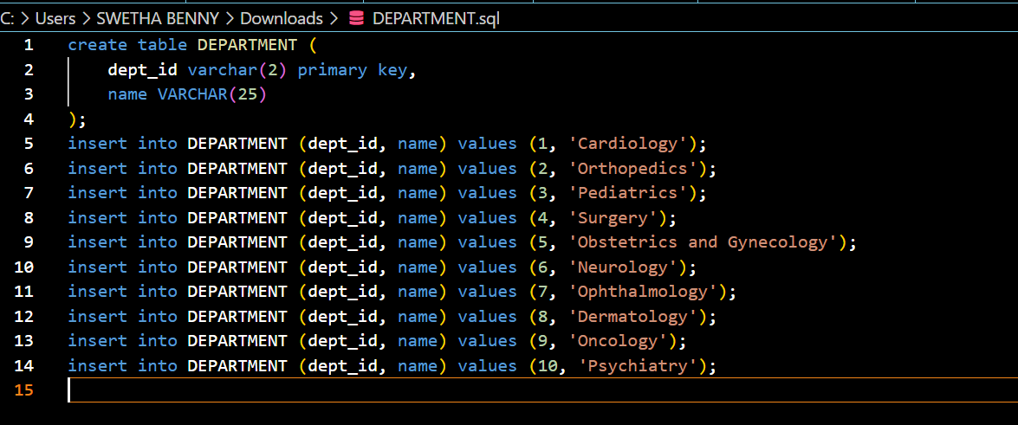

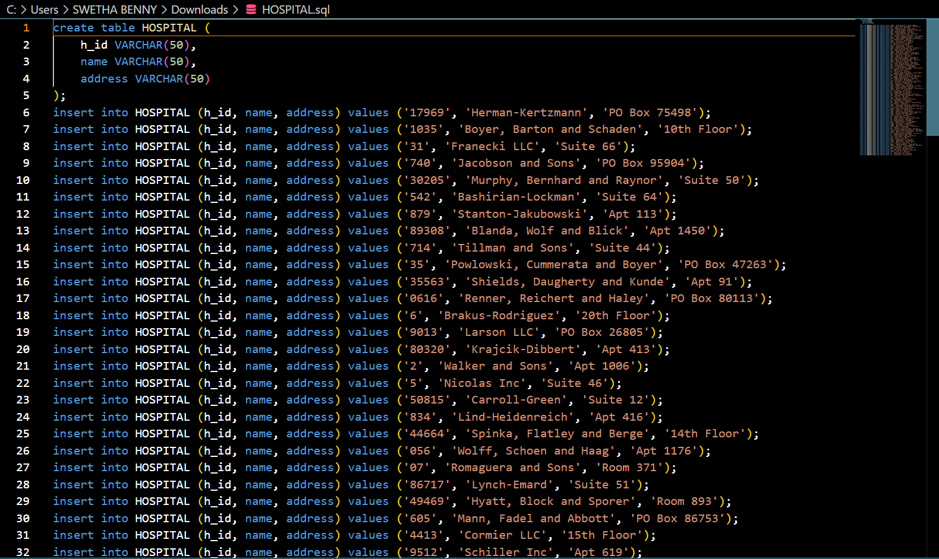

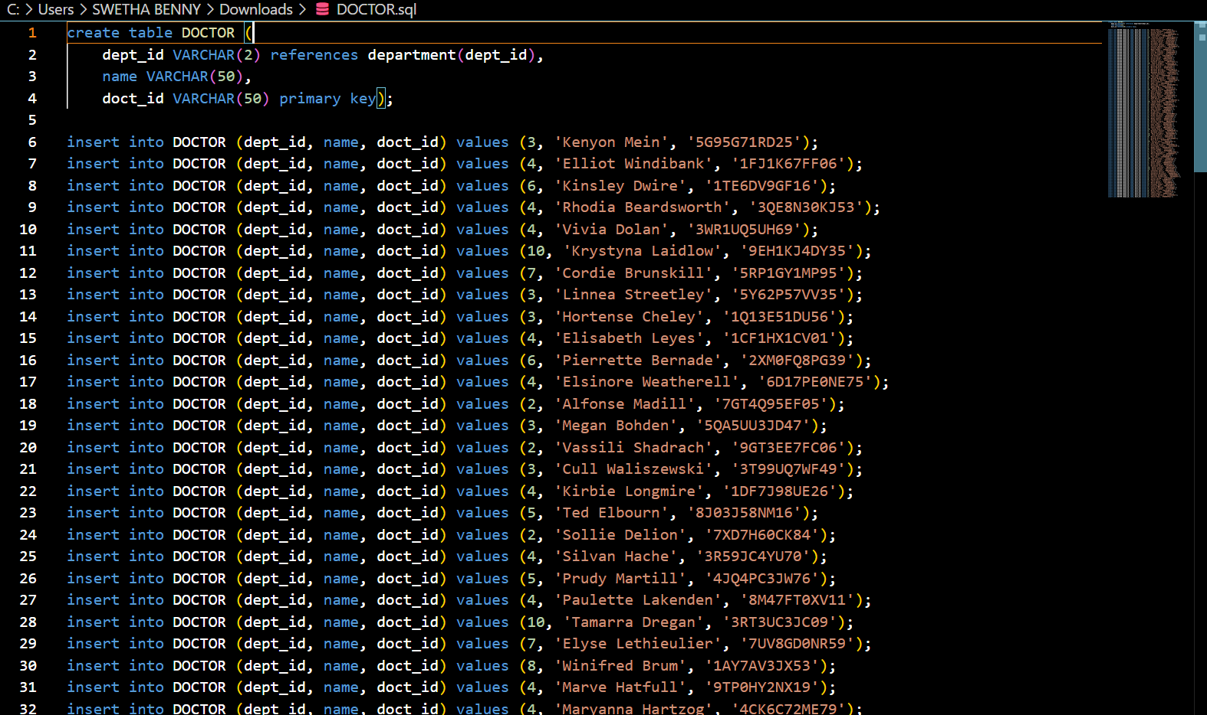

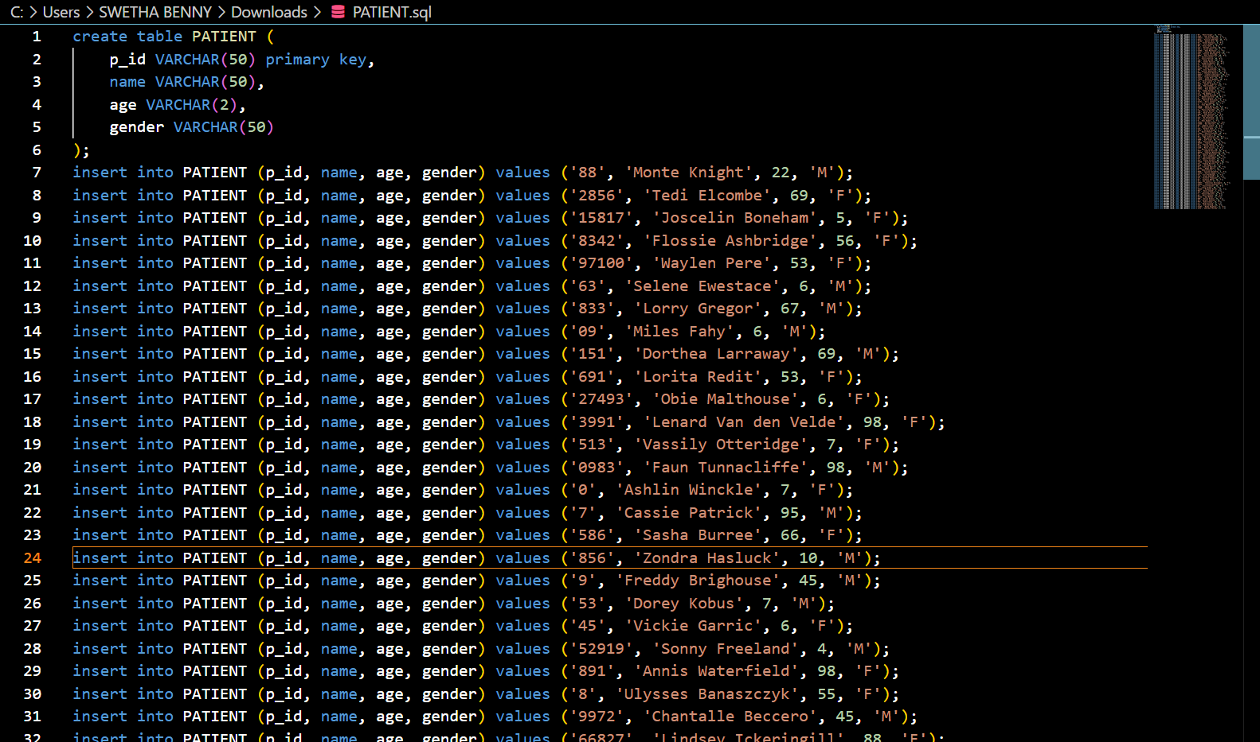

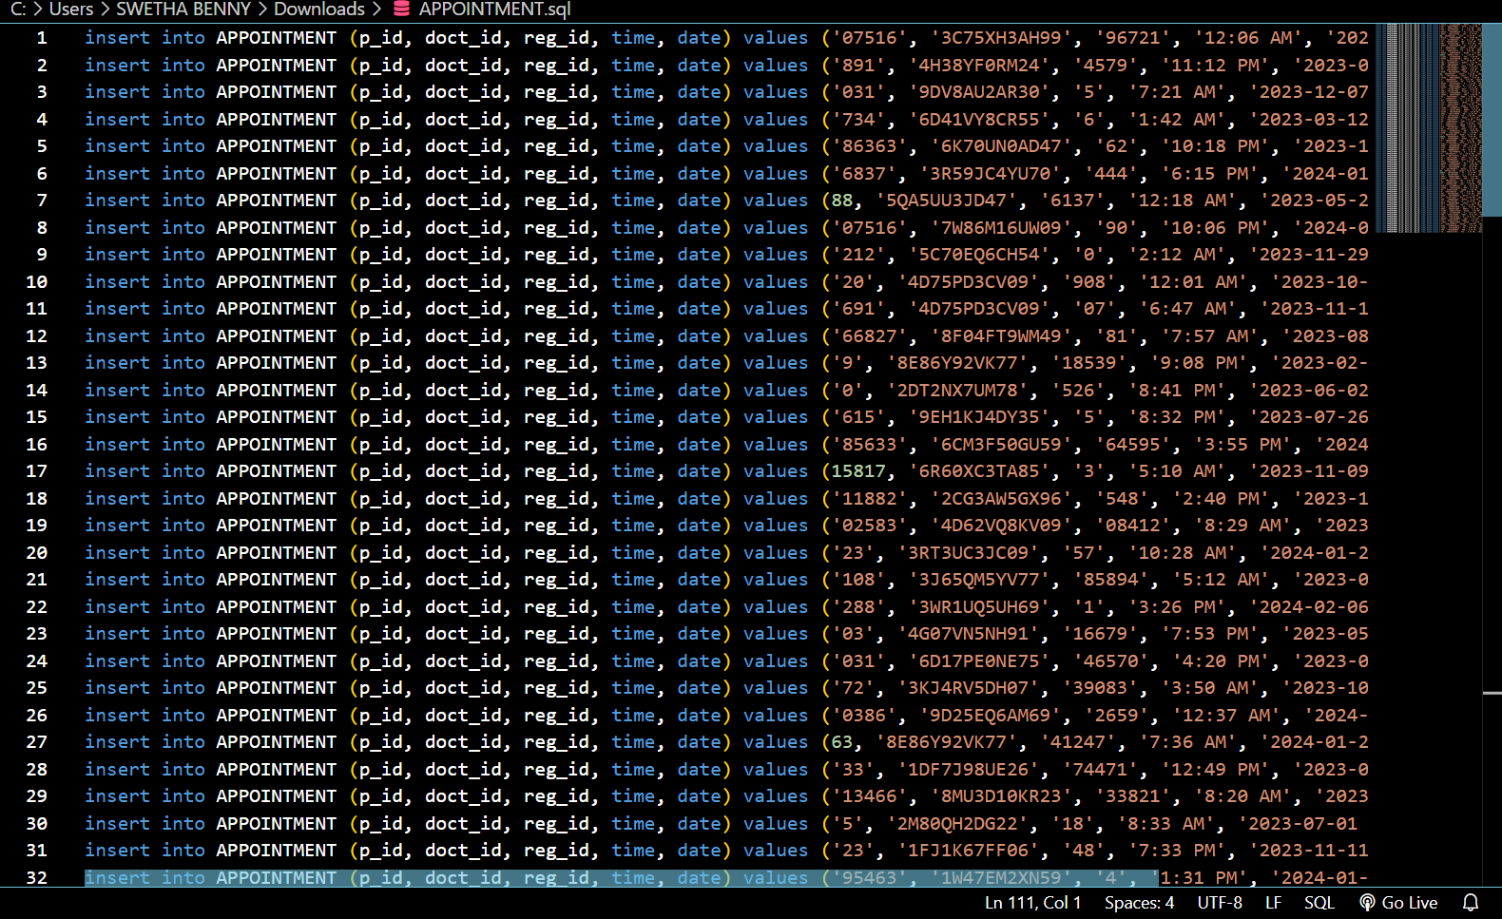

1. Select query without conditions.

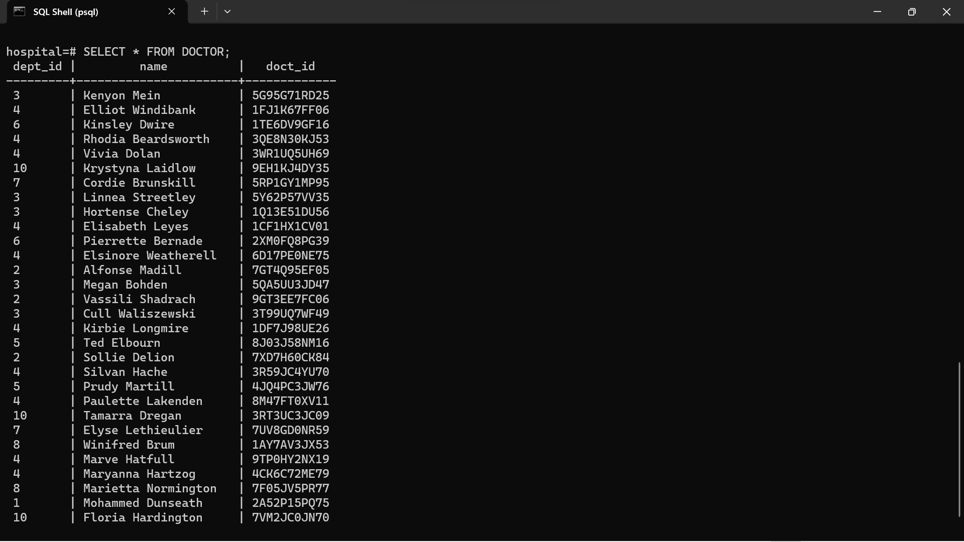

5.Select query with conditions.

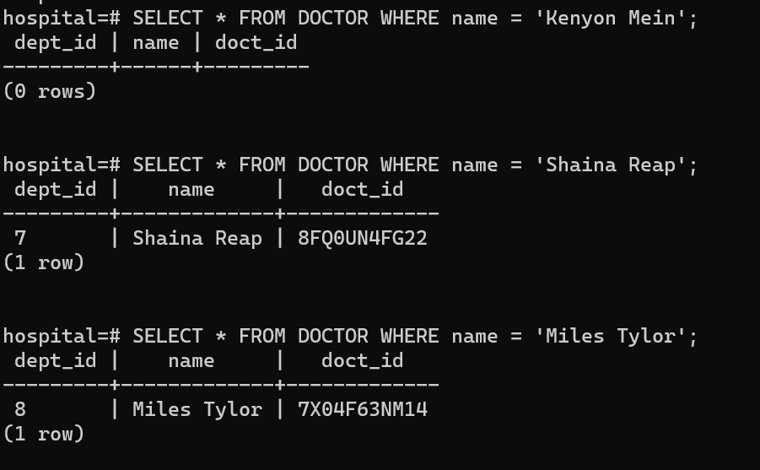

6.Insert query to add new data for all the tables

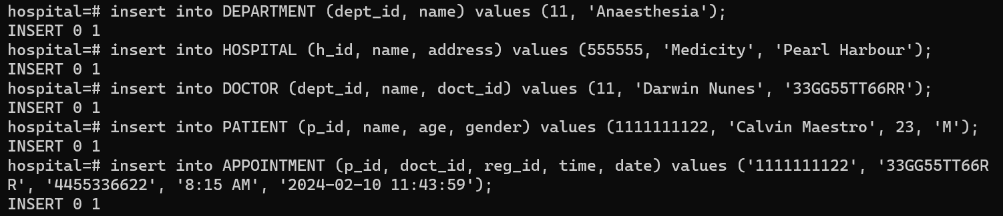

7. Delete query to delete any existing data for all the tables.

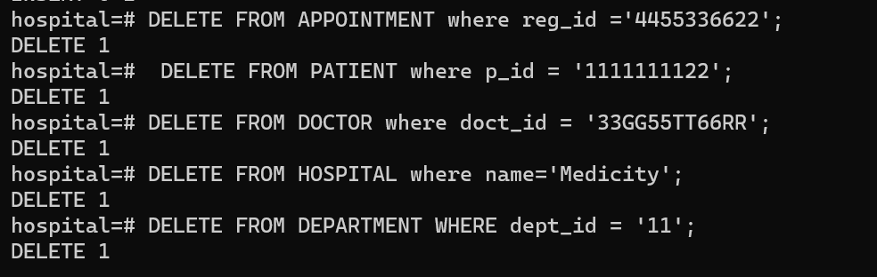

8. Update query to update any existing data for all the tables.

